**EXPERIMENT – 6**

**AIM: -** Write a program to implement error detection and correction using HAMMING code concept. Make a test run to input data stream and verify error correction feature.

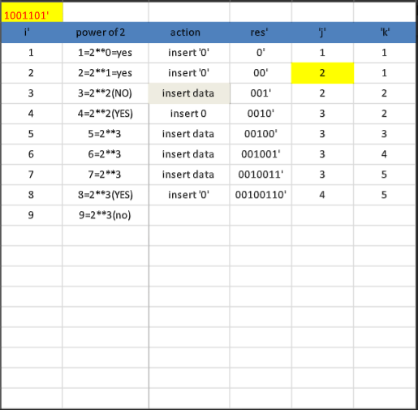

**CODE: -**

def calcRedundantBits(m):  
    # Use the formula 2 ^ r >= m + r + 1  
    for i in range(m):  
        if(2**i >= m + i + 1):  
            return i  
  
def posRedundantBits(data, r):  
    # Redundancy bits are placed at the positions  
    j = 0  
    k = 1  
    m = len(data)  
    res = ''  
    # If position is power of 2 then insert '0' Else append the data  
    for i in range(1, m+r+1):  
        if(i == 2**j):  
            res = res + '0'    
            j += 1  
        else:  
            res = res + data[-1 * k]  
            k += 1  
    # The result is reversed since positions are counted backwards. (m + r+1 ... 1)  
    return res[::-1]  
  
  
def calcParityBits(arr, r):  
    n = len(arr)  
    # For finding rth parity bit, iterate over  
    # 0 to r - 1  
    for i in range(r):  
        val = 0  
        for j in range(1, n + 1):  
  
            # If position has 1 in ith significant  
            # position then Bitwise OR the array value  
            # to find parity bit value.  
            if(j & (2**i) == (2**i)):  
                val = val ^ int(arr[-1 * j])  
                # -1 * j is given since array is reversed  
  
        # String Concatenation  
        # (0 to n - 2^r) + parity bit + (n - 2^r + 1 to n)  
        arr = arr[:n-(2**i)] + str(val) + arr[n-(2**i)+1:]  
    return arr  
  
def detectError(arr, nr):  
    n = len(arr)  
    res = 0  
  
    # Calculate parity bits again  
    for i in range(nr):  
        val = 0  
        for j in range(1, n + 1):  
            if(j & (2**i) == (2**i)):  
                val = val ^ int(arr[-1 * j])  
  
        # Create a binary no by appending  
        # parity bits together.  
  
        res = res + val*(10**i)  
  
    # Convert binary to decimal  
    return int(str(res), 2)  
  
  
# Enter the data to be transmitted  
data = '1011001'  
  
# Calculate the no of Redundant Bits Required  
m = len(data)  
r = calcRedundantBits(m)  
  
# Determine the positions of Redundant Bits  
arr = posRedundantBits(data, r)  
  
# Determine the parity bits  
arr = calcParityBits(arr, r)  
  
# Data to be transferred  
print("Data transferred is " + arr)  
  
# Stimulate error in transmission by changing  
# a bit value.  
# 10101001110 -> 11101001110, error in 10th position.  
  
arr = '10101001110'  
print("Error Data is " + arr)  
correction = detectError(arr, r)  
if(correction==0):  
    print("There is no error in the received message.")  
else:  
    print("The position of error is ",len(arr)-correction+1,"from the left")

**OUTPUT: -**

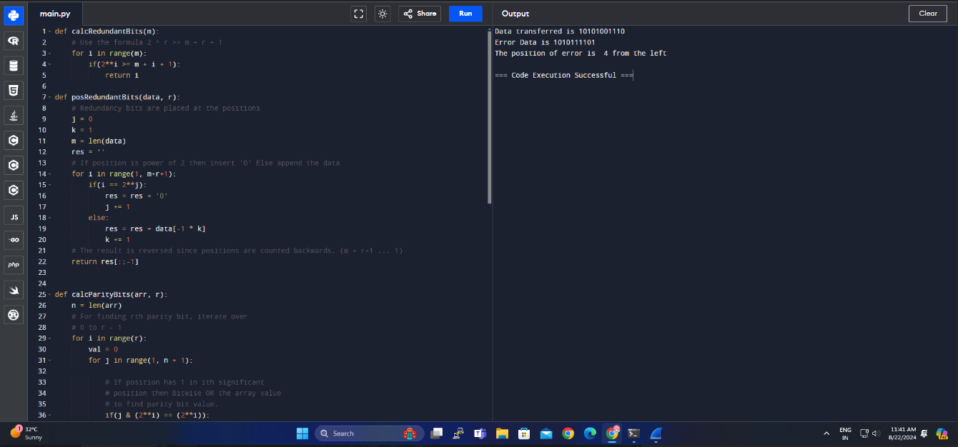

**RESULT: -**

The code for HAMMING CODE have been executed successfully and the output is verified.